Correlation between Human Behavior and Economic Organization Behavior
Eastern Europe - Regional Level Analysis

Andronie Irina Elena
Doctoral Studies Institute
Academy of Economic Studies, ASE
Bucharest, Romania

Abstract— There are a number of factors that determine the behavior of an economic organization. In the specialty literature, the study of organizational behavior is mainly centered on the study of the human resources that work in that organization [1]. This is because the way people act influence the comportment of all the other resources, giving the behavior of the whole economic organization. This paper aims to demonstrate, based on real life indicators, a correlation between human resources behavior and economic organization behavior.
Keywords- organizational behavior, human resources behavior, economic organization, resources.

Introduction
In the frame of the present paper, there is assumed that the behavior of an economic organization is a sum of “behaviors“ of different factors, among them, the most important being the resources that the organization uses. In this context, the first part of the paper presents the main resources used within an economic organization (among them human resources being arguably the most influential), with their interaction and their impact on the behavior of the organization as an entity. The second part of the paper, based on the data gathered from the World Economic Forum Global Competitiveness Report 2016–2017 [2], proves the correlation between the values of human resources behavior indicators and the values of organizational behavior indicators, measured for eight Eastern European countries.

Resources – Key Factors that Determine the Economic Organization Behavior
In our society there are many economic organizations that differ by size, social structure, environment where they function and field of activity. Yet, a precondition of the existence and functioning of any economic organization is the availability of resources necessary for carrying on its activities. The resources necessary for the functioning of each organization are different being split into the flowing categories:
- Informational resources – represent all the information, knowledge and data that a company needs to function;
- Human resources – represents all the people working for the economic organization, including management and operational staff;
- Technologic resources – represents all the technologic equipment used by the economic organization;
- Financial resources – represents all the money needed to finance the activities of the economic organization;
- Material resources – represents all the material consumed by the economic organization to achieve its purposes (offering products/ services to clients).
Each category of resources is dependent on the others, as it is illustrated in figure 1, and has its specific form of manifestation (based on its availability and quality) and “behavior”.
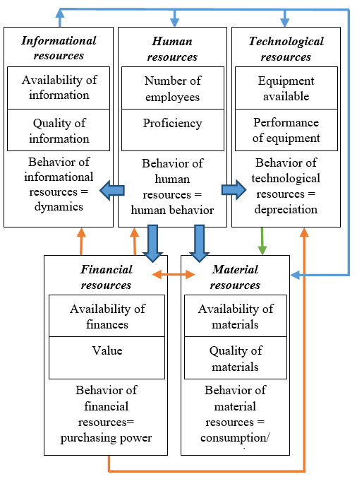
Figure 1. The resources used by an economic organization and their interdependence
From the functional point of view, the behavior of the economic organization is defined by the “behavior” of the resources involved in its functioning:
- Informational resources of an economic organization are manifesting through their availability and quality of the information and their behavior consists of their dynamics; these are important to human resources to plan their activity, to technological resources for their operation and to material resources for planning stocks and choosing the right type of materials; informational resources are influenced by financial resources (buying information) and by human resources.
- Regarding human resources we can consider their number and how they are prepared for doing their tasks and the behavior of this resource is human behavior; they are influenced by informational resources and are motivated to work in the company by finance resource (salaries); human resources influence all the other resources in the economic organization.
- Technological resources are characterized by the number of equipment the organization is using and their performance. Their behavior is given by depreciation and the technological advancement; they are influenced by information resource (regarding their parameters) and they are procured using financial resources. Technological resources influence material resource because stocks are ordered according to technology available.
- Financial resources are represented by availability and value and their behavior is given by the purchasing power that the economic organization uses to ensure all the other resources; they are provided by clients when purchasing the products and services the organization provides. They are influenced by human resources because financial decision is taken by other people.
- Material resources are manifesting through their availability and quality of raw materials and their behavior is given by the consumption of resources and supply; they are influenced by all the other resources and have impact on financial resource because they are transformed in products and services that are sold to clients.
The organizational behavior is given by all the resources involved in the economic organization. In fact the behavior of the economic organization can be considered the sum of the behavior of the resources used.

Human Resources Behavior – Main Component of the Economic Organization Behavior
Human resources’ behavior has an important role because employees’ actions influence the comportment of all the other resources, giving the behavior of the whole economic organization. Human resources are also directly involved in all processes carried on by the economic organization, at all levels. More exactly:
- Human resources behavior influence the behavior of information resources, being responsible for their updating and for their interpretation in the context of the economic organization;
- Human resources behavior involved in a sector of activity influences the behavior of human resources involved in other sectors, as triggers and participants in all processes of economic organization, thereby influencing the economic organization as a whole; behavior of human resources involved in management activities influence the behavior of other categories of human resources through adoption of appropriate decisions; from another point of view the behavior of other categories of human resources influence management decisions through the results obtained (relative to the quantity and quality required), attitude at workplace etc.
- Human Resources behavior influence the behavior of technological resources as the attitude to work of human resources is determined primarily by the conditions created in the workplace; in terms of technology, working conditions depend on performance parameters of technological resources used and also on technological developments; therefore moral depreciation of the equipment used to carry out processes inevitably leads to the need for management decisions regarding technological upgrade, in accordance to the technological progress in the field;
- Human Resources behavior influences the behavior of financial resources, being directly responsible for funding all processes taking place in the economic organization; as a result, the management team identifies and attracts funding sources, adopts and implements an appropriate strategy in the economic context, influencing the financial resources necessary to carry out processes of production and service provision through suitable measures;
- Human Resources behavior influence the behavior of material resources because people are directly responsible for ensuring the material resources of all processes taking place in the economic organization in order to obtain products and delivering services; the way human resources behave influences the consumption of material resources related to operational processes performed by the organization; to improve productivity and quality of processes, human resources can identify and use new material resources, in accordance with the technological progress
- Financial resources are represented by availability and value and their behavior is given by the purchasing power that the economic organization uses to ensure all the other resources; they are provided by clients when purchasing the products and services the organization provides. They are influenced by human resources because financial decision is taken by other people.
From those presented it results that human capital (shareholders, owners, managers, employees, and partners) has a key role (directly and indirectly) on organizational behavior because it determines and is determined by the behavior of other resources in relation to the economic organization (Figure 2).
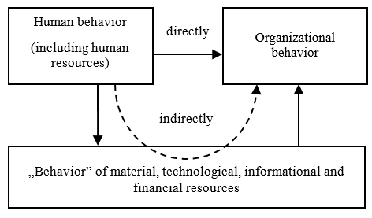
Figure 2. Human behavior influence on the behavior of economic organization he resources used by an economic organization and their interdependence

Indicators Related to Human Resources and Economic Organization Behavior
World Economic Forum defines annually since 2005 a number of 114 indicators that highlight aspects connected to productivity and long term prosperity. The indicators provided are grouped in the report on 12 pillars and are calculated for each country, generating a ranking of its productivity. Most of the indicators provided in the report are obtained from World Economic Forum’s opinion survey containing questions with possible answers based on a scale from 1 (extremely poor—among the worst in the world) to 7 (excellent—among the best in the world).
From all the indicators defined in the 2016-2017 Global Competitiveness Report, a list of 12 indicators were selected, related to both human and organizational behavior. Indicators related to the behavior of human resources are described in Table I and indicators reflecting the behavior of the organization are presented in Table II.
- Indicators related to human behavior
Indicator | Description [2]
Quality of primary education | Executive opinion survey in each country regarding the quality of primary education
Quality of the education system | Executive opinion survey in each country reflecting how well does the education system meet the needs of a competitive economy
Quality of management schools | Executive opinion survey in each country regarding the quality of management schools
Local availability of specialized training services | Executive opinion survey in each country regarding the availability of high-quality, professional training services
Extent of staff training | Executive opinion survey in each country regarding the companies’ investment in training and employee development
Willingness to delegate authority | Executive opinion survey in each country regarding the willingness to delegate authority to subordinates
- Indicators Related to the Behavior of the Economic Organization
Indicator | Description [2]
Ethical behavior of firms | Executive opinion survey in each country rating the corporate ethics of companies (ethical behavior in interactions with public officials, politicians, and other firms)
Efficacy of corporate boards | Executive opinion survey in each country regarding the management accountability to investors and boards of directors
Pay and productivity | Executive opinion survey in each country regarding the correlation between pay and employee productivity
Reliance on professional management | Executive opinion survey in each country about the merits of those who holds senior management positions in companies
Firm-level technology absorption | Executive opinion survey in each country regarding the businesses’ adoption of the latest technologies
Company spending on R&D | Executive opinion survey in each country regarding the extent companies invest in research and development (R&D)

According to the previous section the behavior of the economic organization is determined by the behavior of the human resources involved. In this respect it is assumed that some correlation can be demonstrated between the indicators reflecting the human resource behavior and the indicators related to the economic organization behavior. Figure 3 presents some possible correlation between the presented indicators. In the following section we aim to demonstrate correlations between human and organizational indicators according to the figure below and at the group level.
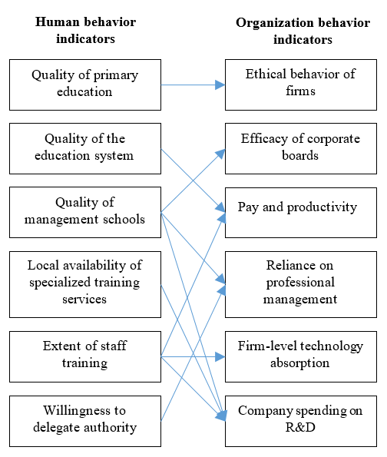
Figure 3. Influence of human behavior on the behavior of the economic organization

Eastern Europe - Regional Level Analysis regarding the Correlation between Human Resources Behavior and Economic Organization Behavior
In order to demonstrate the correlations between the indicators described in the previous section, values for a number of representative countries from Eastern Europe, given in the 2016-2017 Word Economic Forum Global Competitiveness Report, were analyzed. The countries for which the indicators were analyzed are: Romania, Bulgaria, Serbia, Poland, Hungary, Moldova, Czech and Ukraine.
Table III presents the values of the indicators related to the behavior of human resources, while Table IV presents the values of the indicators related to the behavior of the economic organizations. All indicator values are on a scale from 1 to 7 as described in the previous section.
- Indicators related to human behavior
Indicator | Romania | Bulgaria | Serbia | Poland | Hungary | Moldova | Czechia | Ukraine
Quality of primary education | 3.9 | 4.1 | 3.9 | 4.5 | 3.4 | 4.0 | 4.8 | 4.4
Quality of the education system | 2.8 | 3.3 | 3.2 | 3.6 | 2.9 | 3.2 | 3.9 | 4.0
Quality of management schools | 3.4 | 3.6 | 3.7 | 4.2 | 4.1 | 3.3 | 4.2 | 3.8
Local availability of specialized training services | 3.9 | 3.7 | 3.9 | 5.0 | 4.0 | 3.7 | 5.3 | 4.2
Extent of staff training | 3.5 | 3.5 | 3.2 | 4.0 | 3.4 | 3.1 | 4.5 | 3.7
Willingness to delegate authority | 3.6 | 3.2 | 2.9 | 3.8 | 3.0 | 3.4 | 4.1 | 3.2

- Values of the indicators related to the behavior of the economic organizations
Indicator | Romania | Bulgaria | Serbia | Poland | Hungary | Moldova | Czechia | Ukraine
Ethical behavior of firms | 3.3 | 3.6 | 3.3 | 4.0 | 2.6 | 3.1 | 3.8 | 3.4
Efficacy of corporate boards | 4.2 | 4.9 | 4.5 | 5.1 | 4.3 | 4.4 | 5.6 | 4.1
Pay and productivity | 3.7 | 4.0 | 3.5 | 4.1 | 3.5 | 3.9 | 4.7 | 4.4
Reliance on professional management | 3.9 | 3.7 | 3.3 | 4.3 | 3.6 | 3.5 | 5.3 | 3.5
Firm-level technology absorption | 4.3 | 4.7 | 3.8 | 4.7 | 3.4 | 4.0 | 5.1 | 4.4
Company spending on R&D | 2.8 | 3.5 | 2.7 | 3.4 | 3.0 | 2.2 | 4.1 | 3.3

There are two possibilities for analyzing the data in Table 3 and Table 4. The first type of analysis could have as an object pairs of indicators (one describing the human resource behavior and the other describing the organizational behavior). The second type of analysis can be performed on all indicators in the same time. For the last one is necessary to work with an average of this indicators and this can be easily done because all the indicators are represented on a scale from 1 to 7.
Figure 4 presents the correlation between willingness to delegate authority and reliance on professional management.
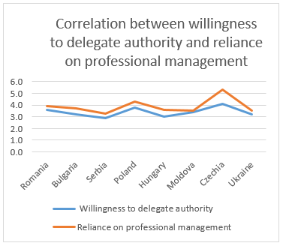
Figure 4. Correlation between willingness to delegate authority and reliance on professional management
We can observe that the two graphs have similar profile indicating that a correlation exists between the two indicators for the country analyzed. It appears that in countries where the willingness to delegate authority is higher also the reliance on professional management in higher.
Similar analyses can be performed on other pairs of indicators or on an average of the indicators as calculated in Table V.
- Values of the indicators related to the behavior of the economic organizations
Indicator (average) | Romania | Bulgaria | Serbia | Poland | Hungary | Moldova | Czechia | Ukraine
Human behavior (average) | 3.5 | 3.6 | 3.5 | 4.2 | 3.5 | 3.5 | 4.5 | 3.9
Organizational behavior (Average) | 3.7 | 4.1 | 3.5 | 4.3 | 3.4 | 3.5 | 4.8 | 3.9

We can observe that in most of the analyzed countries there is a strong correlation between the average of the human resources indicators and organization behavior indicators. This fact confirms the assumption from the first paragraph of the present paper and strongly links human actions to organizational behavior.
The dependence observed in Table V can be also plotted to better illustrate the correlation of the average indicators. Figure 5 illustrates this dependence.
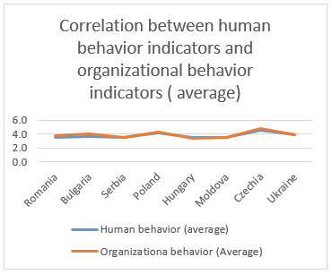
Figure 5. Correlation between willingness to delegate authority and reliance on professional management

Conclusions
In the context presented in this paper the behavior of human resources fundamentally influences the behavior of economic organizations, at all levels, because human resources are directly responsible for all the processes in a company. For this reason, in specialty literature, the concept of organizational behavior is regarded as human resources behavior, the behavior of the other categories of resources being insignificant compared to the influence that behavior of human resources has.

References

- Andrew Creed , Organisational Behaviour, Oxford University Press ,2011;
- World Economic Forum, The Global Competitiveness Report 2016–2017;
- Hawkins, Peter. Leadership Team Coaching: Developing Collective Transformational Leadership, Second Edition. Kogan Page. © 2014
- Gifford, Jonathan. 100 More Great Leadership Ideas: From Successful Leaders And Managers Around The World. Marshall Cavendish. © 2013;
[5] Judge, T., Robbins, S. P., Organizational behavior. Upper Saddle River, NJ: Prentice Hall, 2011;
AUTHORS PROFILE
Andronie Irina Elena is PhD. student at the Doctoral Studies Institute of the Academy of Economic Studies, Bucharest, Romania, studying the impact of organizational behavior on their economic performance.

